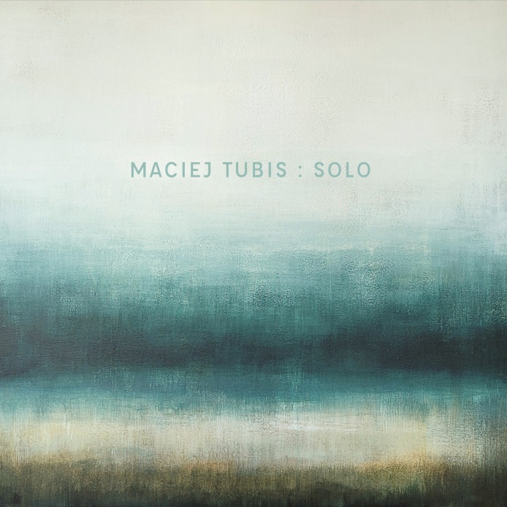
Maciej Tubis – Komeda: Reflections
Release (CD/Digital): September 16, 2022
Maciej Tubis has done his share of piano playing in Poland and abroad. This classically trained pianist has developed his unique style as the leader of Tubis Trio with which he recorded four albums, all well received by critics and public. Head over heels with the piano and fully devoted to the sensitive spirit of this instrument, Maciej continues his search for original arrangements with his first ever solo album “Komeda: Reflections.”
When asked about the idea for the project, Tubis said: Komeda’s work has always been close to my heart, but the turning point came with my doctoral dissertation on the influence of classical pianism on the aesthetics of improvisation. After defending my thesis, I was invited to play a concert which enjoyed a truly enthusiastic reception and raised questions as to plans for recording an album.
The sound of piano on “Komeda: Reflections” has been expanded to include preparations and an analog synthesizer. Maciej’s inspirations with minimalism have been supplemented with influences from electronic, film and neoclassical music. The main component is improvisation, which is executed in the way that does not blur the melody, phrases, and themes, so characteristic of Komeda’s works.
There have been multiple albums featuring Komeda's music over the last ten years, and I was simply afraid of creating something that would be viewed as secondary. It was also about the difficulty of playing the piano solo. It's a lot easier to play in a band, even in a duo, than to do a solo program. That is why I decided to use synthesizers and was not afraid of production work, that is recording many piano tracks - continues the pianist.
The album’s tracklist includes the legendary "Rosemary's Lullaby", but in a surprisingly bold interpretation. This one, as well as a few other pieces ("The Law and the Fist", "Le Départ") have been enhanced by use of additional instruments. Of course, there is also a solo piano ("My Ballad", "After the Catastrophe") and swinging motifs ("Two People with a Wardrobe"). “Komeda: Reflections” is a mature, original, and all together captivatingly intimate and sincere look at the work of the artist gone too soon leaving behind music that – even after many years – can still surprise with new, interesting interpretations.
Maciej Tubis – fortepian (1-7), Sequential Prophet~6 (1, 3, 5)
Tracklist:
1. Sleep Safe and Warm / Kołysanka Rosemary
2. My Ballad / Moja ballada
3. The Law and the Fist / Nim wstanie dzień
4. Ballad for Bernt
5. Le Départ
6. After the Catastrophe / Po katastrofie
7. Two Men and a Wardrobe / Każdy szafę ma

Music: Krzysztof Komeda
Production and arrangements: Maciej Tubis
Recording, mixing, and mastering: Karol Mańkowski
Piano tuning: Damian Maksymiuk
Painting: Pola Yankee
Photography: Rafał Masłow
Cover design: Katarzyna Bolewska
Concerts in 2022:
September 17, 2022 - OLSZTYN - Filharmonia Warmińsko-Mazurska
September 21, 2022 - ŁASK - Łaski Dom Kultury
September 23, 2022 - CZĘSTOCHOWA - OPK Gaude Mater
September 28, 2022 - ŁÓDŹ - Łódzki Dom Kultury
September 30, 2022 - POZNAŃ - CK ZAMEK
October 1, 2022 - WAŁBRZYCH - Filharmonia Sudecka
October 2, 2022 - KĘDZIERZYN-KOŹLE - Miejski Ośrodek Kultury
November 2, 2022 - KWIDZYN - Teatr Miejski

